

# TR REGISTER CONCOURS PROGRAM

Premium fuel is available in town on Mount Barker road. Mount Barker road has numerous restaurants and café’s and alcohol can be purchased at The German Arms. The Manna has a courtyard area with tables where casual gatherings are possible.

**Friday 17th October**

**Registration 4pm – 5pm**

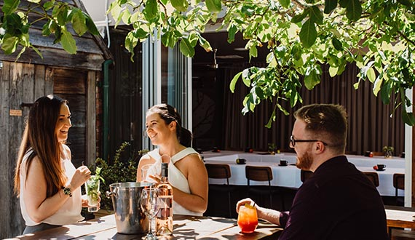The Haus Restaurant Walnut Room – directly across the road from ‘The Manna’

**Welcome Evening 6pm – 11pm**

Join us in The Walnut room at The Haus Restaurant where you can mingle with old friends or new. The event includes the courtyard so wander out and enjoy the garden. Substantial canapes will be served through the evening and drinks will be at your own expense. This is a casual evening with a little housekeeping regarding the events in the days ahead.

**Saturday 18th**

**Concours 10am – 2.30pm**

Start your engines and get your cars down to the Hahndorf primary school just off the Mount Barker road and into Balhannah road. Follow the marshals’ directions to park your car on the oval and in the class of your choosing. Walk back down the road and you are on Mount Barker road, the main street of Hahndorf about 400m from The Manna with plenty of places for a coffee or lunch on the way.

We have invited the TSOA of SA to participate in the display and we will have signs up to attract the passing traffic that typically wander the streets of Hahndorf.

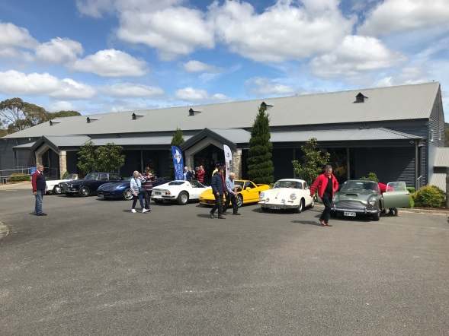**Presentation Dinner 6.30 – 11.30**

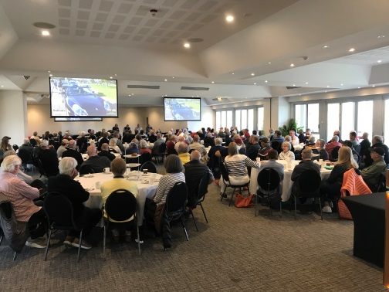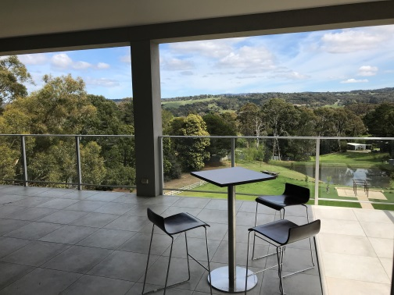A bus will collect revelers from the accommodation for the short drive to the Adelaide Hills Conventions Centre where the formal dinner will be held and awards presented. This is a popular venue for the local car events and is a great venue with wonderful outlook. Naturally there will be music after or you can enjoy the balcony overlooking the gardens. Make sure you talk to any newcomers to the event so they feel welcome!

The bus will do return trips at regular intervals.

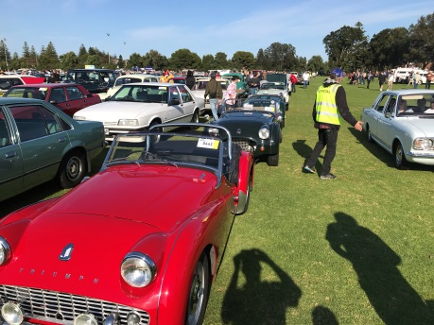**Sunday 19th**

**Bay to Birdwood 8.30am to 3pm**

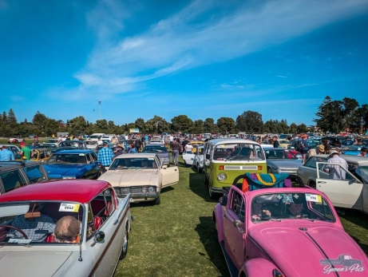The is an opportunity to participate in one of Australia’s greatest motoring events with about 1500 historic cars of all vintages enjoying the drive from ‘The Bay’ to the National Motoring Museum at Birdwood. The residents of Adelaide line the streets with as many notable cars lining the course as there are on the road! Be prepared to spend the 2 hours waving to the crowds as you drive through the streets of Adelaide and into the hills. The club has organised a group entry which allows us to start and park at Birdwood as a group. We have invited the TSOA of SA to participate to make it a day of Triumph! Enjoy the cars either at the starting oval or at the paddocks of cars at the end with many people enjoying picnics by their cars. Entry to the National Motoring Museum is included in the entry fee.

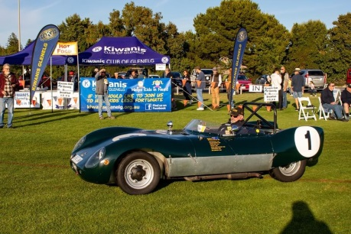

At your leisure you can make your way back to Hahndorf via a pleasant 30 minute drive.

If you are not interested in the Bay to Birdwood, the make the most of the activities in and around Hahndorf which includes

* Beerenberg Farm
* Hans Heyson ‘The Cedars’ (museum and art gallery)
* Ambleside Distillery
* Hahndorf Lavender farm

Or enjoy some of the very local winery’s such as Hahndorf Hill, Nepenthe’s, The Lane or Shaw & Smith to name a few.

**Members Forum 4.30pm - 5.30pm**

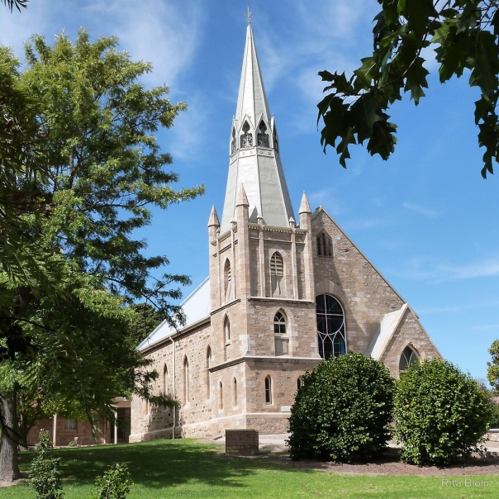The members forum will be held in the afternoon to accommodate the bay to Birdwood participants and will held at the St Paul’s Lutheran church hall, a walk of 500m and will be limited to an hour.

**Farewell Dinner 6.30pm – 9.30pm**

The farewell dinner will be also be held at the St Paul’s Lutheran church hall. This is catered by the church and is a BYO affair so drop into the bottle shop for you drink of choice before wandering down there. This is an opportunity to say farewell to those not participating in the After Tour so get up and mingle.

## The After Tour

We are located in the Adelaide Hills between the great wine regions of The Barossa Valley and McLaren Vale with no shortage of other winery areas in between. While we could easily spend the 3 days at the multiple wineries, in the interest of sobriety we have chosen to mix it up a bit to take advantage of the area

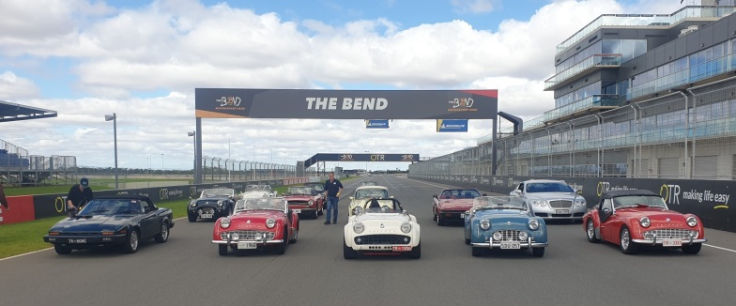**Monday 20th**

**Lunch & Laps at ‘The Bend’**

Sign in 11-11.15am

Driver Briefing 11.30

On track (approx.) 12pm

Lunch 12.30pm

If you are not a motorsport buff ‘The Bend’ is our local racetrack used by the Supercars located at Tailem Bend about an hour drive from Hahndorf. This is an opportunity to get onto a racetrack without the serious stuff like licenses and helmets. The laps are behind a pace car although it is still at a spirited pace as well you are on a racetrack. This is followed by lunch at the Rydges hotel on track. The local Register group has done this previously and all enjoyed the experience. The return home will be via a members property at Callington to inspect their car collection.

Alternate Event

**Walking Tour of Hahndorf**

If you are not interested in a racetrack or just had enough of cars then join the Walking Tour of Hahndorf for a 90 minute lesson on the history of Hahndorf.

Dinner is by your own arrangement.

**Tuesday 21st**

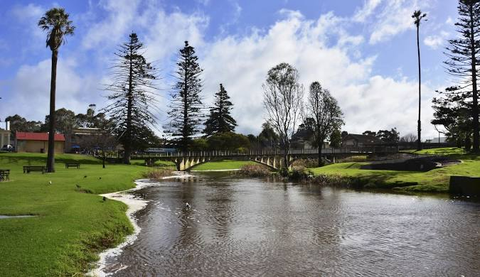**Scenic drive to Strathalbyn and lunch at local winery 10 am – 2.30pm**

Join us in a leisurely drive to the town of Strathalbyn and enjoy wandering around this historic town. You can drop in to Gilberts Motor Museum which was the site of the Holden dealer of the district. The museum regularly rotates the stock using cars from the community for their displays.

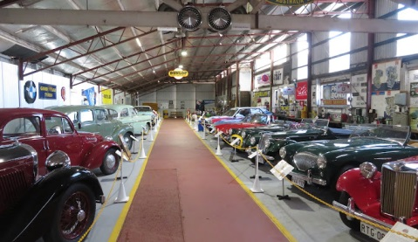Strathalbyn is also the home of Collectables Classics, a notable dealer in Classic motor vehicles. If you are not interested in cars and more cars then wander the town and look at craft and antique shops or just have a coffee.

Once you have enjoyed Strathalbyn then we take a 15 minute drive to a local winery to enjoy lunch before making you way back to Hahndorf to relax for the remainder of the day. Dinner is by your own arrangement.

**Wednesday 22nd**

**McLaren Vale and Lady Bay Resort 10am – 2.30pm**

The final event of the after tour is a drive to the coast via McLaren Vale. Stop in McLaren Vale for a coffee and stroll after the 40 minute drive. Following that we head to the coast for lunch at the Lady Bay resort for lunch while enjoying the panoramic view over the golf course and coast. Following lunch take a drive down to the beach before heading back to Hahndorf to conclude the events of the week.

Dinner is by your own arrangement.

